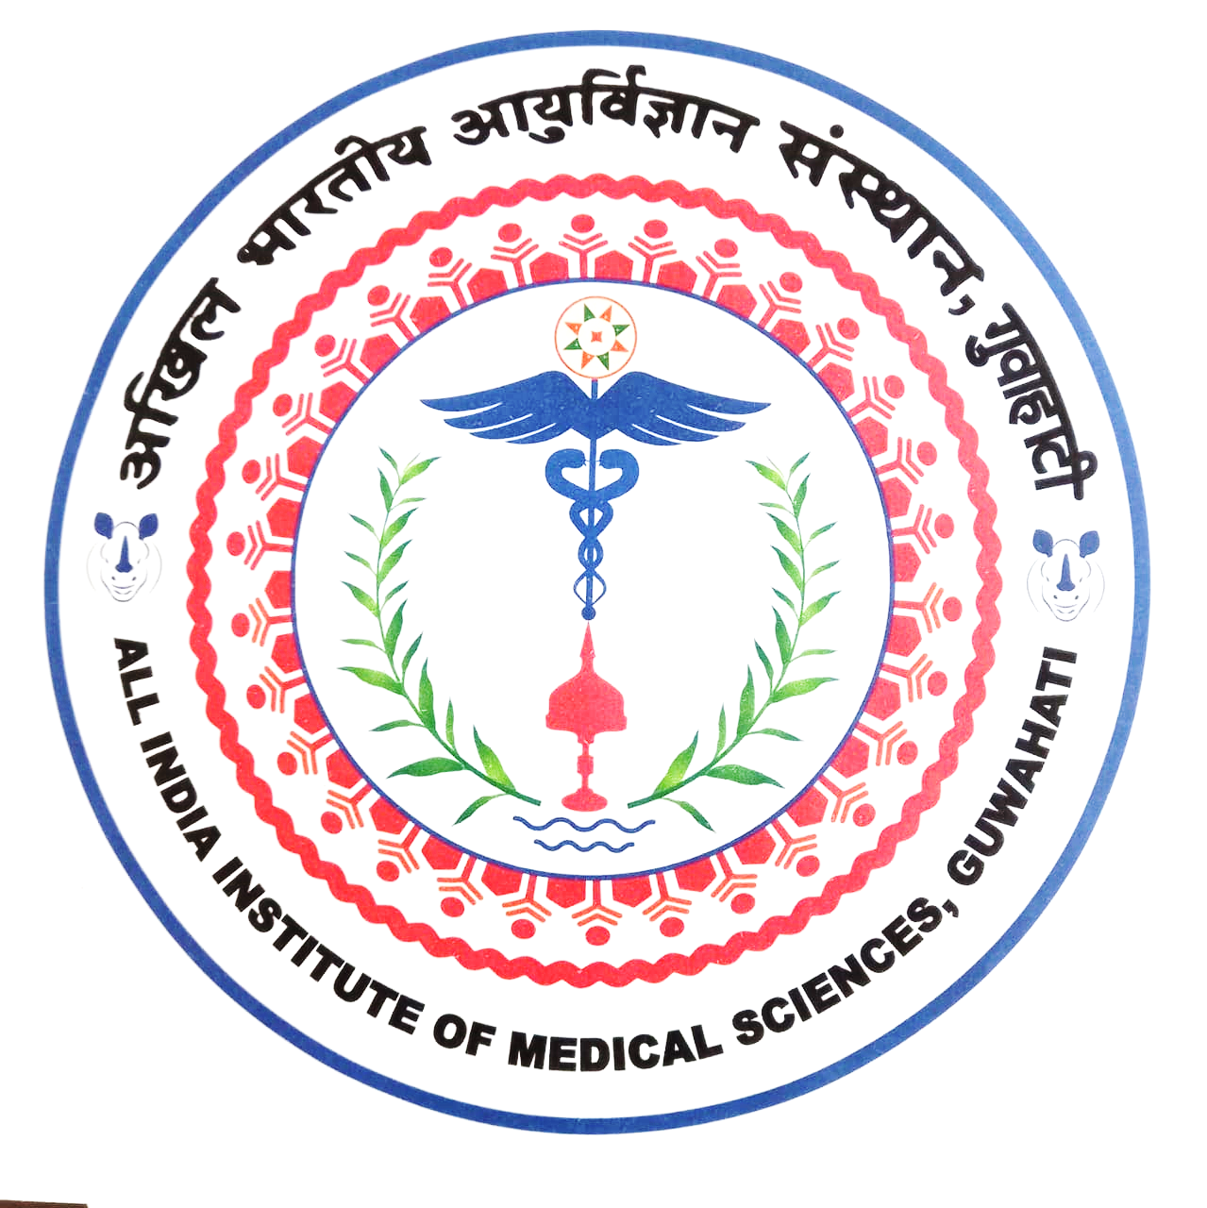 | अखिल भारतीय आयुर्विज्ञान संस्थान (एम्स), गुवाहाटी  All India Institute of Medical Sciences, Guwahati  स्वास्थ्य और परिवार कल्याण मंत्रालय,भारत सरकार के तत्वावधान में एक वैधानिक निकाय  (A statutory body under the aegis of Ministry of Health and Family Welfare, GoI )

TENTATIVE ACADEMIC CALENDAR FOR MBBS 2020 BATCH

12.01.2021 | Beginning of 1st semester
22.4.21-28.4.21 | 1st end semester exam
29. 4.21 | Beginning of 2nd semester
18.10.2021-28.10.2021 | 1st pre prof exam
9.11.21-16.11.21 | 1st professional MBBS Exam
10.01.2022 | Beginning of 3rd Semester
28.03.2022 -31.03.2022 | 3rd Mid Semester Exam
06.06.2022 -18.06.2022 | 3rd Semester End Exam
20.06.2022 | 4th Semester -Beginning
10.10.2022- 20.10.2022 | 4th Semester End Exam
21.10.2022 | 5th Semester – Beginning
25.12.2022-01.01.2022 | Winter vacation
20.02.2023- 04.03.2023 (Pre-Prof) | 5th Semester End Semester Exam
15.03.2023 -31.03.2023 | 2nd MBBS professional Exam
12.04.2023 | 6th Semester- Beginning
06.09.2023- 16.09.2023 | 6th Semester End Semester Exam
18.09.2023 ---20.01.2024 | 7th Semester
21.01.2024 to 28.01.2024 | Study Leave
29.01.2024- 07.02.2024 | Pre-Prof MBBS III (Part-1)
19.02.2024-28.02.2024 | Professional Exam MBBS III (part I)
07.03.2024 | 8th Semester-Beginning
1.06.2024- 15.06. 2024 | SUMMER BREAK
5.09.2024-14.09.2024 | 8th Semester End Semester Exam
16.09.2024 | 9th Semester -Beginning
24th December-1st January 2025 | WINTER BREAK
28.02.2025- 15.03.2025 | Pre Prof MBBS III(Part-2)
24.03.2025-10.04.2025 | Professional Exam MBBS (part II)
16.04.25-15.04.26 | Internship

NB: Dates are tentative. Subjected to modification by Dean(A) office as per the Govt. holiday list or any unforeseen event.

Changsari, Assam PIN - 781101

